**INTELLIGENT ATTENDANCE SOLUTION FOR EXAMINING THE PRESENCE OF MGNREGA WORKERS**

A MINI PROJECT REPORT

***Submitted by***

**AISWARYA R 1805067**

**GOKULNATH J 1805076**

**SWATHI R 1805124**

**UVASHRI S 1805125**

***in partial fulfillment for the award of the degreee of***

**BACHELOR OF ENGINEERING**

***in***

**COMPUTER SCIENCE AND ENGINEERING**



**COIMBATORE INSTITUTE OF TECHNOLOGY**

***(Government Aided Autonomous Institution Affiliated to Anna University)***

**COIMBATORE-641 014**

**ANNA UNIVERSITY** - **CHENNAI 600 025**

**APRIL 2021**

**COIMBATORE INSTITUTE OF TECHNOLOGY**

***(A Govt. Aided Autonomous Institution Affiliated to Anna University)***

**COIMBATORE – 641 014**

**BONAFIDE CERTIFICATE**

Certified that this mini project **“INTELLIGENT ATTENDANCE SOLUTON FOR EXAMINING THE PRESENCE OF MGNREGA WORKERS”** is the bonafide work of **AISWARYA R(1805067), GOKULNATH J(1805076), SWATHI R(1805124), UVASHRI S (1805125)** under my supervision during the academic year 2020-2021.

**Dr.G.Kousalya, M.E.,Ph.D Mrs.D.Mohana, M.E.,**

**HEAD OF THE DEPARTMENT, ASSISTANT PROFESSOR,**

Department of CSE Department of CSE,

Coimbatore Institute of Technology, Coimbatore Institute of Technology,

Coimbatore – 641 014. Coimbatore – 641 014.

Certified that the candidates were examined by us in the project work viva voce examination held on …………………

**Internal Examiner External Examiner**

Place:

Date:

**TABLE OF CONTENTS**

# **CHAPTER NO. TITLE PAGE NO.**

# **ACKNOWLEDGEMENT 5**

# **ABSTRACT 6**

### LIST OF FIGURES 7

**LIST OF ABBREVIATION 9**

1. **INTRODUCTION 10**
   1. INTRODUCTION 10
   2. GOOGLE TREND ANALYSIS **11**
2. **LITERATURE SURVEY 12**
3. **SYSTEM SPECIFICATION 15**

3.1 SOFTWARE SPECIFICATION 15

* 1. HARDWARE SPECIFICATION 15

1. **SYSTEM ANALYSIS 16**

4.1. EXISTING SYSTEM 16

4.2. PROPOSED SYSTEM 16

4.3. METHODOLOGIES 17

4.3.1. CNN 17

4.3.2. MTCNN 18

4.3.3. ONE STAAGE DETECTOR 19

4.3.3.1. YOLO V1 AND YOLO V2 19

4.3.3.2. YOLO V3 20

4.3.4. PREPROCESSING 22

4.3.5. FEATURE EXTRACTION 23

4.3.5.1. FACENET 23

4.3.5.2. TRIPLET LOSS 24

4.3.6. CLASSIFICATION 24

1. **SYSTEM IMPLEMENTATION**  26

5.1 OVERVIEW 26

5.2 MODULES 26

5.2.1. FACE DETECTION FROM 26

GROUP PHOTO

5.2.2. EXTRACTION OF DETECTED FACES 27

5.2.3. FACE DETECTION FROM INDIVIDUAL 27

PHOTO

5.2.4. DATASET TRAINING 27

5.2.5. GROUP PHOTO – FACES VERIFICATION 27

5.2.6. UPDATION OF ATTENDANCE 28

6 **RESULTS 29**

7 **CONCLUSION AND FUTURE WORK 41**

8 **REFERENCES 42**

**ACKNOWLEDGEMENT**

**----------------------------------------------------------------------------------------------------**

**ACKNOWLEDGEMENT**

We express our sincere thanks to our Secretary **Dr.R.Prabhakar** and our Principal **Dr.V.Selladurai** for providing us a great opportunity to carry out our work. The following words are a small part to express our gratitude to them. This work is the outcome of their inspiration and product of plethora of their knowledge and rich experience.

We would like to record our gratitude to **Prof.K.S.Palanisamy, M.E.,** Joint Coordinator, Department of Computer Science and Engineering & Information Technology for his enthralling support.

We record the deep sense of gratefulness to **Dr.G.Kousalya**, Head of the Department of Computer Science and Engineering, for his encouragement during this tenure.

We equally tender our sincere thankfulness to our project guide **Mrs.D.Mohana**, Assistant Professor, Department of Computer Science and Engineering, for her valuable suggestions and guidance during this course.

During the entire period of study, the entire staff members of the Department of Computer Science and Engineering & Information Technology have offered ungrudging help. It is also a great pleasure to acknowledge the unfailing help we have received from our friends.

It is matter of great pleasure to thank our parents and family members for their constant support and co-operation in the pursuit of this endeavour.

**ABSTRACT**

**-----------------------------------------------------------------------------------------------------------**

**ABSTRACT**

MGNREGA (Mahatma Gandhi National Rural Employment Guarantee Act). This Acts aims to enhance livelihood security in rural areas by providing at least 100 days of wage employment in a financial year to every household whose adult members volunteer to do unskilled manual work. MGNREGA mainly implemented by gram panchayats. Government is using NREGA Soft for handing all MGNREGA related works starting from Job card creation to Payment. Unemployed volunteers have to register in gram panchayats for MGNREGA. In each gram panchayats Technical Assistant will entry all the data in NREGA soft. A lot of manual work is involved in this process. Attendance is not fool proofed, any time before entry it can be changed. No time bound attendance system. In order to get the better of, Intelligent attendance solution is applied on a mobile based Application. From anywhere at any time to access data as well as monitoring became hassle free. Since it follows time bound activity, attendance pool can be avoided to the maximum. The intelligence system used here is real time face recognition system. A technical assistant will capture a group photo thrice a day with the help of this app. The effective image processing and detection algorithms will be implemented to process the image and identify the individual among the group of people. Finally, it auto generates the attendance.

**LIST OF FIGURES**

**FIGURE NO. TITLE PAGE NO.**

4.1 CNN MODEL 18

4.2 MTCNN STRUCTURE 18

4.3 SXS GRID REPRESENTATION OF YOLO 19

4.4 YOLO V3 ALGORITHM 21

4.5 FLOWCHART FOR YOLO ALGORITHM 22

4.6 FACENET MODEL 23

4.7 TRIPLET LOSS 24

4.8 SUPPORT VECTOR MACHINE 25

6.1 DATASET HOLDER 29

6.2. a INDIVIDUAL PHOTO 30

6.2. b INDIVIDUAL PHOTO 30

6.3 TRAINING DATASET FOLDER 31

6.4 TRAINING OUTPUT 31

6.5. a ARRAY FORMAT OF FACES 32

6.5. b ARRAY FORMAT OF FACES 32

6.6 SAMPLE GROUP PHOTOS 33

6.7. a OUTPUT FROM YOLO DETECTION 33

6.7. b OUTPUT FROM YOLO DETECTION 34

6.8. a EXTRACTED FACES 34

6.8. b EXTRACTED FACES 35

6.9 OUTPUT OF YOLO FILE COMPILATION 35

6.10 DIRECTORY OF FINAL ATTENDANCE FILE 36

6.11. a PREDICTED FACES WITH LABELS 36

6.11. b PREDICTED FACES WITH LABELS 37

6.11. c PREDICTED FACES WITH LABELS 37

6.12 SAMPLE.XLSX 38

6.13 SEPARATE SHEETS FOR EACH MONTH 38

6.14 EXCEL SHEET FOR APRIL MONTH BEFORE 39

UPDATING

6.15 WORKSHEET FOR APRIL MONTH AFTER 40

UPDATING

**LIST OF ABBREVIATIONS**

CNN Convolutional Neural Network

ANN Artificial Neural Network

MGNREGA Mahatma Gandhi National Rural Employment Guarantee

Act

MTCNN Multi-task Cascaded Convolutional Neural Networks

DCNN Deep Convolutional Neural Network

LBPH Local Binary Patterns Histogram

YOLO You Only Look Once

SSD Single shot detector

IDE Integrated development environment

SVM Support vector machine

NMS Non Maxima Suppression

GPS Global Positioning System

RAM Random Access Memory

**INTRODUCTION**

**--------------------------------------------------------------------------------------**

**CHAPTER 1**

**INTRODUCTION**

**1.1.Introduction:**

Government is using NREGA Soft for handing all MGNREGA related works – Starting from Job card creation to Payment. Unemployed volunteers have to register in gram panchayats for MGNREGA. In each gram panchayats Technical Assistant will entry all data in NREGA soft. This leads to a lot of manual work where time consumption exceeds. Attendance is not fool proofed, any time before entry it can be changed. No time bound attendance system. A lot of intelligence solution can be provided like biometrics, finger print, but the better solution can be achieved through face recognition which is cost-free. In order to get the better of, Intelligent attendance solution is applied. Face recognition technologies have made many amendment in this transmuting world. In this project, system detects the faces from the image provided. Numerous algorithms and techniques have been developed for ameliorating the performance of the system. The concept to be implemented here is Deep Learning. Finally, attendance will be marked automatically and maintained in the worksheet.

**1.2.Google trend analysis:**

The diagram shown below displays the google trend analysis about the domain of this project “Image Processing”.

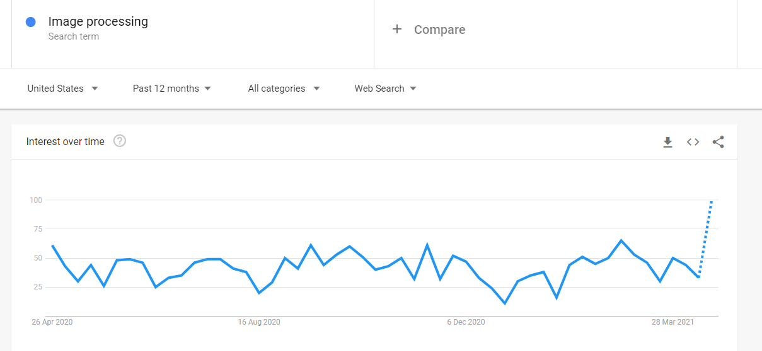

.

**LITERATURE SURVEY**

**----------------------------------------------------------------------------------**

**CHAPTER 2**

**LITERATURE SURVEY**

**2.1.** **Human Face Identification using LBP and Haar like Features for Real Time Attendance Monitoring (2019)**

**AUTHORS:** Mayank Kumar Rusia , Dushyant Kumar Singh , Mohd.Aquib Ansari

**DESCRIPTION**

In this paper, the LPBH and Haar-like features with cascade classifier is used for real time face identification. Here Confusion matrix is generated after experimentation to show the accuracy of the algorithm on created datasets. This gives 81.6% accuracy. The accuracy can be improved by increasing number of classes and respective dataset quantity, as well as training the model with deep architecture. Here the accuracy for gray scale images are much better than color images

**ADVANTAGES**

1. Good accuracy and efficiency can be achieved.

**DISADVANTAGES**

1. Storage capacity required is very high.

**2.2.** **Face Recognition based Attendance System using Haar Cascade and Local Binary Pattern Histogram Algorithm (2020)**

**AUTHORS:** Bharath Tej Chinimilli, Anjali T, Akhil Kotturi, Vihas Reddy Kaipu, Jathin Varma Mandapati

**DESCRIPTION**

In this paper, haar cascade is used for face detection and LBPH is used for face recognition. In haar cascade classifier, cascade function is trained and detect features from image. False positive rates has been reduced in this method. This system recognizes unintentional changes like wearing glasses or growing beard.

**ADVANTAGES**

1. False positive rate is reduced.

**DISADVANTAGES**

1. Number of images taken for training is high.

**2.3. Convolutional Neural Network (CNN) for Image Detection and Recognition(2018)**

**AUTHORS:** Rahul Chauhan, Kamal Kumar Ghanshala, R.C Joshi

**DESCRIPTION**

CNN – a class of ANN . It composed of multiple layers like convolution layer, pooling layers, fully connected layers. It follows back - proportion algorithm.

**ADVANTAGES**

1. Accuracy and performance is high and also computationally efficient.
2. Faster in implementation and easier to understand.

3. Automatically detects the important features without any human supervision.

**2.4.** **Face Detection and Recognition Based on Visual Attention Mechanism Guidance Model in Unrestricted Posture (2020)**

**AUTHOR:** Zhenguo Yuan

**DESCRIPTION**

YOLO-V3 is an improved model based on YOLO-V2. By using multiscale prediction to detect the final object, its network structure is more complicated than YOLO-V2. YOLO-V3 can predict the bounding boxes of different scales, which can detect small objects more effectively , but there are still missing detections for partially occluded face object.

**ADVANTAGES**

1. High accuracy and implementation is faster.
2. Processing time is low.

**2.5.** **Face Recognition System using Facenet Algorithm for Employee Presence (2020)**

**AUTHOR:** Ferry Cahyono, Wirawan, Reza Fuad Rachmadi

**DESCRIPTION**

Deep Convolutional Neural Network (DCNN) that maps images of a person's face into Euclidean spaces which are also called embedding. In this, faces in the dataset are compared with faces that are extracted from the facenet algorithm. the face recognition process is carried out with five stages consisting of face input preprocessing, feature extraction, classification, and face recognition.

**ADVANTAGES**

1. High accuracy in face recognition when compared with Openface algorithm which is the development of FaceNet algorithm.

**DISADVANTAGES**

1. Dataset used is very large. To overcome this, pre – trained model is used.

**SYSTEM SPECIFICATION**

**---------------------------------------------------------------------------------------**

**CHAPTER 3**

**SYSTEM SPECIFICATION**

### 3.1 SOFTWARE SPECIFICATION:

* IDE : Anaconda Navigator
* Coding Language : Python

### 3.2 HARDWARE SPECIFICATION:

* Operating system : Windows 10
* Processor : Intel core i5
* Hard disk : 1TB
* RAM : 8GB (maximum)

**SYSTEM ANALYSIS**

**---------------------------------------------------------------------------------------**

**CHAPTER 4**

**SYSTEM ANALYSIS**

##### 4.1 EXISTING SYSTEM

In order to handle attendance system in MGNREGA scheme Government uses a software called NREGA. In this software attendance system is not automated. A technical assistant should login to the software and manually needs to update the attendance for individual workers in individual profile. Considering updating attendance for more than thirty workers per day in this work flow, a lot of manual work is involved. This may lead to high chances of not fool proofing of attendance. The technical assistant can update the attendance anytime anywhere which leads to insatiable attendance work.

Drawbacks of existing system:

• Lot of man power is involved.

• Less responsibility towards MGNREGA scheme.

• Utilizes valuable time of technical assistant since no time bound attendance.

• Attendance is not fool proofed, any time before entry it can be changed.

**4.2.PROPOSED SYSTEM**

The main objective of the project is to update the attendance for all the workers at once using an intelligence solution. A lot of intelligence solution like fingerprint, biometrics can be used but all these are not cost effective and also the required equipments will not be available in every gram panchayat. So we proposed a face recognition automated attendance solution. This system works based on image processing. Individual photos will be trained for whom attendance needs to be updated. Every day the supervisor will take a group photo from which individual faces are extracted and face embedding are created for every faces from which attendance is marked automatically month wise in worksheet. YOLO – (You Only Look Once) algorithm is used to implement face detection since it takes less run time and gives better result at extraction level.

**4.3. METHODOLOGIES:**

In this project, the face recognition process is carried out with five stages consisting of face input pre-processing, feature extraction, classification, and face recognition results. Then it will be implemented into the recognition system in real-time by comparing faces in the database with faces detected and extracted from the group photo of the employees.

**4.3.1. CNN:**

A **Convolutional Neural Network (ConvNet/CNN)** is a Deep Learning algorithm which can take in an input image, assign importance (learnable weights and biases) to various aspects/objects in the image and be able to differentiate one from the other. The pre-processing required in a ConvNet is much lower as compared to other classification. The role of the ConvNet is to reduce the images into a form which is easier to process, without losing features which are critical for getting a good prediction.

There are three layers in convolutional neural networks ,

1. Convolutional layer
2. Pooling layer
3. Fully connected layer

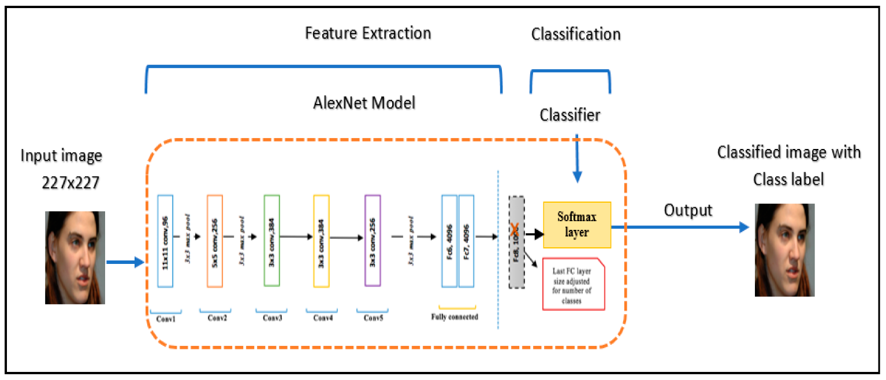

Fig 4.1 :CNN model

**4.3.2. MTCNN:**

**MTCNN** or Multi-Task Cascaded Convolutional Neural Networks is a neural network which detects **faces** and **facial** landmarks on images. [This model](http://arxiv.org/abs/1604.02878) has three convolutional networks (P-Net, R-Net, and O-Net) and is able to outperform many face-detection benchmarks while retaining real-time performance.

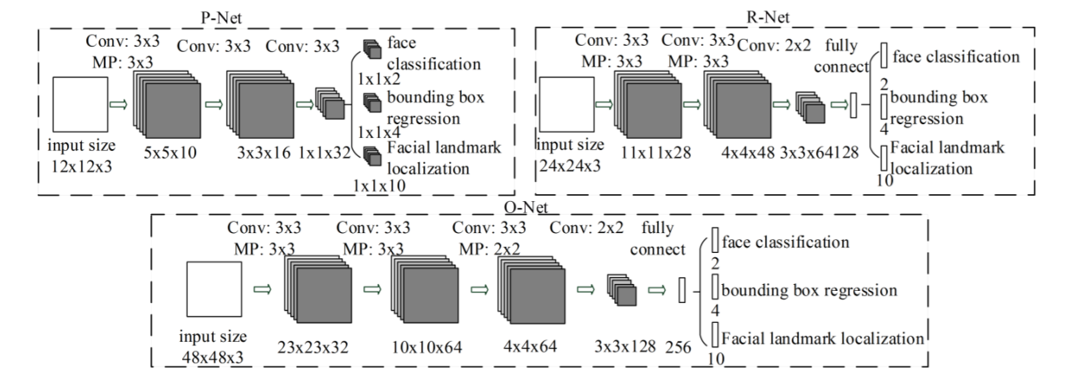

Fig 4.2 :MTCNN structure

**4.3.3. ONE STAGE DETECTORS:**

Two stage detectors provide adequate accuracy, but the time taken for computation is high. Therefore, to process in less time by managing sufficient accuracy, one stage detectors are proposed. Some algorithms in one stage model are SSD and the variants of YOLO. By improving the architecture of two stage models and introducing some changes such as eliminating pipeline, one stage model has achieved excellent speed. But, it has not attained sufficient accuracy at the same time.

**4.3.3.1. YOLO V1 AND YOLO V2:**

YOLO, an input picture is distributed to a system of S×S grids [8]. The detection of the object depends on every grid of the input image. Grid cells are employed to predict targets inside boundary boxes. Five parameters are predicted for every boundary box. These five elements are i, j, k, l, and c. In the input picture, the centre of target inside the box is denoted by 'i' and 'j' coordinates. Here, 'k', 'l', and 'c' represent height, width, and score for confidence respectively. 'c' is measured as the probability of containing the target inside boundary box. For every cell in the network, it computes confidence for 'n' bounding boxes. The predicted result is encoded into a tensor as S × S × (n × 5+ p). YOLO v1 also has many limitations. Therefore, the use of YOLO v1 is restricted to some extent. Limitations of YOLO version1 are based on the closeness of the objects in the picture. If the objects appear as a cluster, they could not find the small objects. Yolo v2 uses darknet19, which has convolutional layers in it.

Since, there are many limitations in Yolo v1 and Yolo v2, Yolo v3 is used for detection in our system which results in better efficiency and accuracy which also leads in less processing time.



**Fig 4.3 :** S×S grid representation of YOLO

**4.3.3.2. YOLO V3:**

Object detection is used in many fields of human life, for example, health and education, etc. As all these fields are growing rapidly, so to match their requirements, one stage models also need improvement. The next advanced variant of YOLO is version 3 that uses logistic regression to compute the target score. It gives the score for all targets in each boundary box. YOLO v3 can give the multilabel classification because it uses a logistic classifier for each class in place of the soft-max layer used in YOLO v2. YOLO v3 uses darknet 53. It has fifty-three layers of convolution. These layers are more in-depth compared to darknet 19 used in YOLO v2. Darknet-53 contains mainly 3x3 and 1x1 filters along with bypass links.

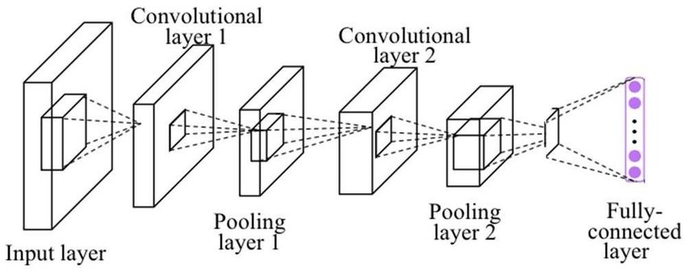

Fig 4.4: YOLO v3 algorithm

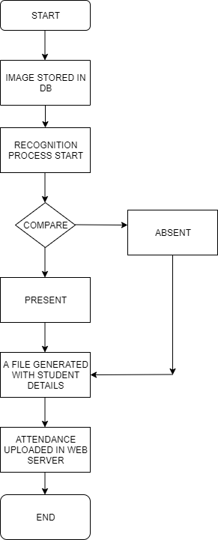

Fig 4.5: Flowchart for YOLO algorithm

**4.3.4. PRE-PROCESSING:**

At the pre-processing stage, three processes were carried out, namely, detection, resizing, and cropping faces using the library's help from Multi-Task Cascaded Convolutional Neural (MTCNN). Detection was used to determine the position of the face in a given image which was then realized in the form of a bounding box. Then implemented the cropping based on the bounding box. After obtaining a face image would be scaled (resize) according to the input size of the model.

**4.3.5. FEATURE EXTRACTION:**

**4.3.5.1. FACENET:**

FaceNet was built by Google researchers using a Deep Convolutional Neural Network (DCNN) that maps images of a person's face into Euclidean spaces (collections of geometrical points) which are also called embedding. Embedding is obtained from the level of similarity and differences in faces, so that if the face has a similarity (smaller distance) the value will get closer, and if the face is different (larger distance) the value will get farther. In general, feature extraction using the FaceNet model, the input images will be getting into the deep learning architecture and then into normalized L2 layer and the result is facial features (embedding). The focus on training a model to create embeddings directly (rather than extracting them from an intermediate layer of a model) was an important innovation in this work.

These embeddings are trained using Triplet Loss.



Fig 4.6 :FaceNet model

Feature extraction of the FaceNet architectural model using the Triplet Loss function makes similar images closer, and makes different images farther away. Feature extraction produced from FaceNet has high quality facial features (embedding) with 128 dimensions.

**4.3.5.2. TRIPLET LOSS:**

It is a distance based loss function that operates on three inputs:

* 1. anchor (a) is any arbitrary data point,
  2. positive (p) which is the same class as the anchor
  3. negative (n) which is a different class from the anchor

Mathematically, it is defined as:

**L=max(d(a,p)−d(a,n)+margin,0).**

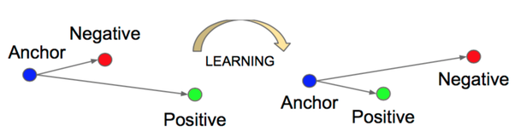

Fig 4.7: Triplet loss

**4.3.6. CLASSIFICATION:**

Face recognition classification in this system uses SVM, because it has good performance and is widely used in face recognition. SVM works by giving dividing boundaries to 2 adjacent classes. Margin is the closest point between Hyperplane and the closest point of each class which is then called the Support Vector Machine. Linear Support Vector Machine (SVM) is very effective and widely used when separating face embedding vectors. By adjusting linear SVM to training data and setting 'kernel' attribute to 'linear'. In making predictions, will use the probability used to set it to be true. In classifying the data is divided into 80% training data and 20% test data. The two groups of data will be processed by training and save the SVM classification model in a file. Classification performance will be evaluated using a confusion matrix.



Fig 4.8 : Support Vector Machine (SVM)

**SYSTEM IMPLEMENTATION**

**-----------------------------------------------------------------------------------------------**

**CHAPTER 5**

**SYSTEM IMPLEMENTATION**

**5.1.OVERVIEW**

Attendance system using face recognition though it’s common but by taking group photo will results in less time consumption and better efficiency. With this, the extra feature of taking group photo thrice a day is also included in order to monitor the presence of workers. For detecting the faces, some of the algorithms like yolo and mtcnn are used.

**5.2. MODULES**

The modules used in the system are,

* Face detection from group photo
* Extraction of detected faces.
* Face detection from individual photo
* Dataset training
* Group photo - faces verification
* Updation of attendance.

**5.2.1. FACE DETECTION FROM GROUP PHOTO:**

Face detection is implemented using YOLO (You Only Look Once). The main advantage in YOLO is multiple faces detected from a group photo in a single process. Group photo is loaded in the sample folder in order to implement yolo in it. Bounding boxes are drawn for individual detected faces . Bounding boxes are removed for faces which has less confidence and threshold value. Threshold value is calculated using Non Maxima suppression (NMS) value. A new file will be created in the output folder with the bounding boxes for the faces along with the number of faces detected.

**5.2.2. EXTRACTION OF DETECTED FACES:**

Faces that are detected from the YOLO algorithm in the bounding boxes are extracted individually and saved locally in the folder named dataset. This will be the required input to be tested for face recognition and for final attendance updation.

**5.2.3. FACE DETECTION FROM INDIVIDUAL PHOTO:**

In order to recognise the faces extracted from yolo, individual faces should be trained for better recognition and accuracy. Dataset is created by converting video into frames which is sent by the individual workers. The dataset is loaded into MTCNN model for extracting only the faces with the dimension of (160,160) . Each extracted faces are converted to array and are zipped in a file with an extension .npz (faces.npz).

**5.2.4. DATASET TRAINING:**

Facenet Keras weight model is loaded in a file to apply facenet algorithm. Face embeddings are created for the faces in the npz file in the form of array of 128 vectors along with the labels ,which is the name of the individuals. These arrays along with the labels are zipped in the form of embeddings.npz which is later used for face verification.

**5.2.5. GROUP PHOTO - FACES VERIFICATION:**

Extracted faces in dataset folder from YOLO is resized to the dimension of (160,160) in order to apply facenet algorithm. Face embedding is created for extracted faces and zipped in testembeddings.npz . A loop is iterated for the faces in zipped file and mapped with the labels and faces in the embeddings.npz . Faces which has maximum accuracy in embedding faces is assigned with corresponding labels and those labels were appended in a list called names.

**5.2.6. UPDATION OF ATTENDANCE:**

A worksheet is created with 12 sheets each sheet for each month along with names and date. Python library called openpyxl is used to update attendance in worksheet. System date and time is extracted using datetime python library in order to identify the sheet and column in which attendance should be updated. A loop is iterated for the names in the particular sheet and mapped with the names in list called names. If names in worksheet exist in the list of identified names, attendance is updated as ‘p’ or else updated as ‘a’.

**RESULT**

**--------------------------------------------------------------------------------------**

**CHAPTER 6**

**RESULT**

Since individual dataset is required for training, fig 6.1 shows the folder for individual.

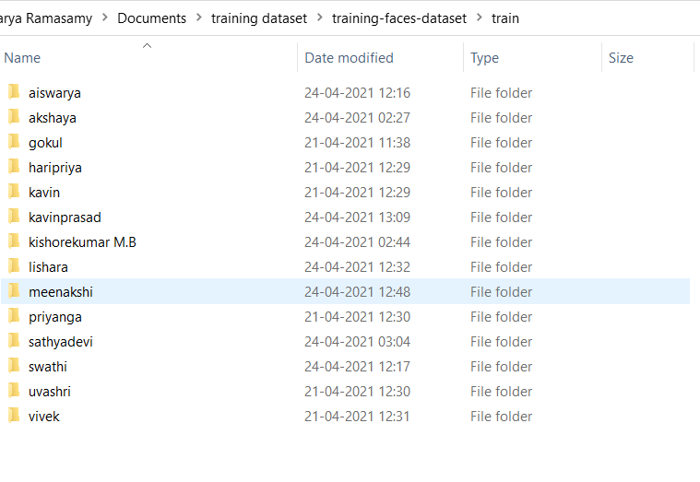

**Fig 6.1: dataset folder**

fig 6.2 a and b shows how individual photos are extracted from a video clip and saved as images

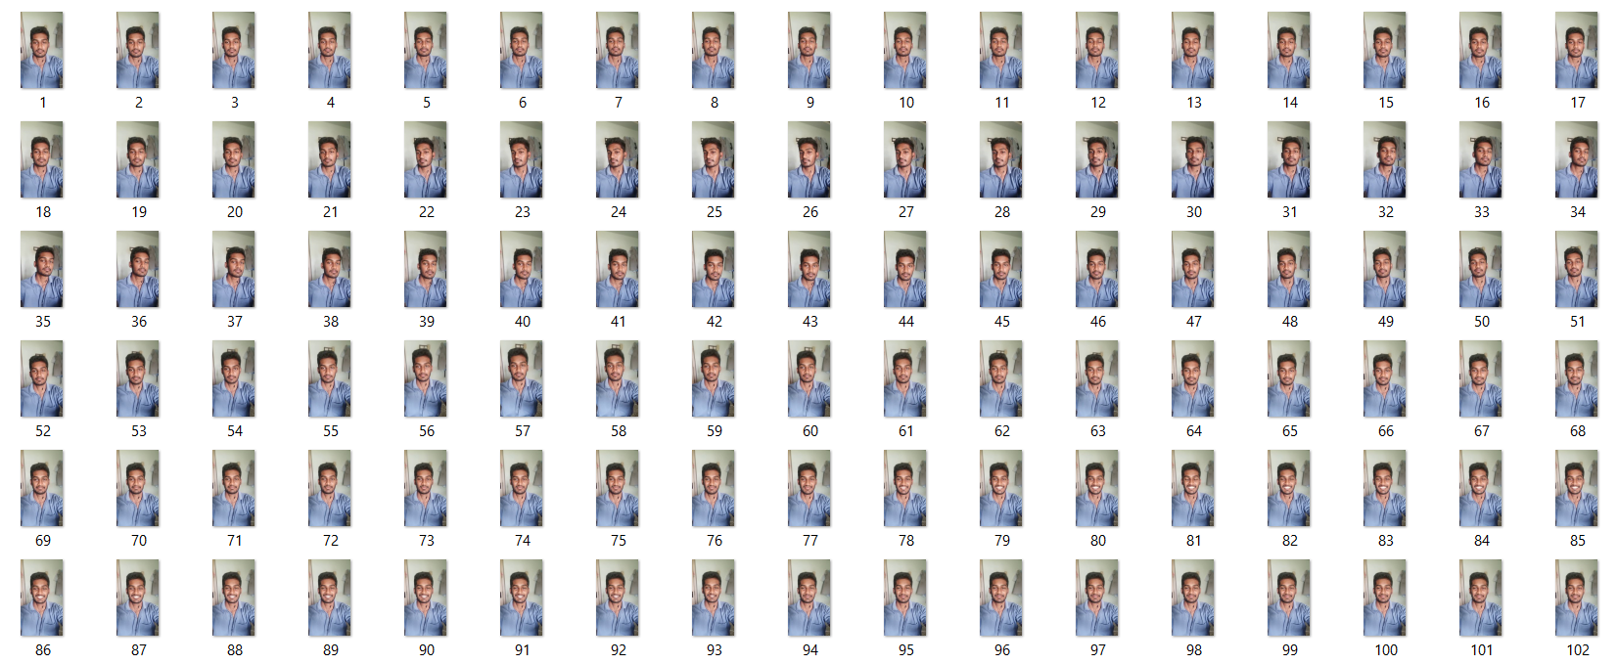

**Fig:6.2. (a) individual photo**

18

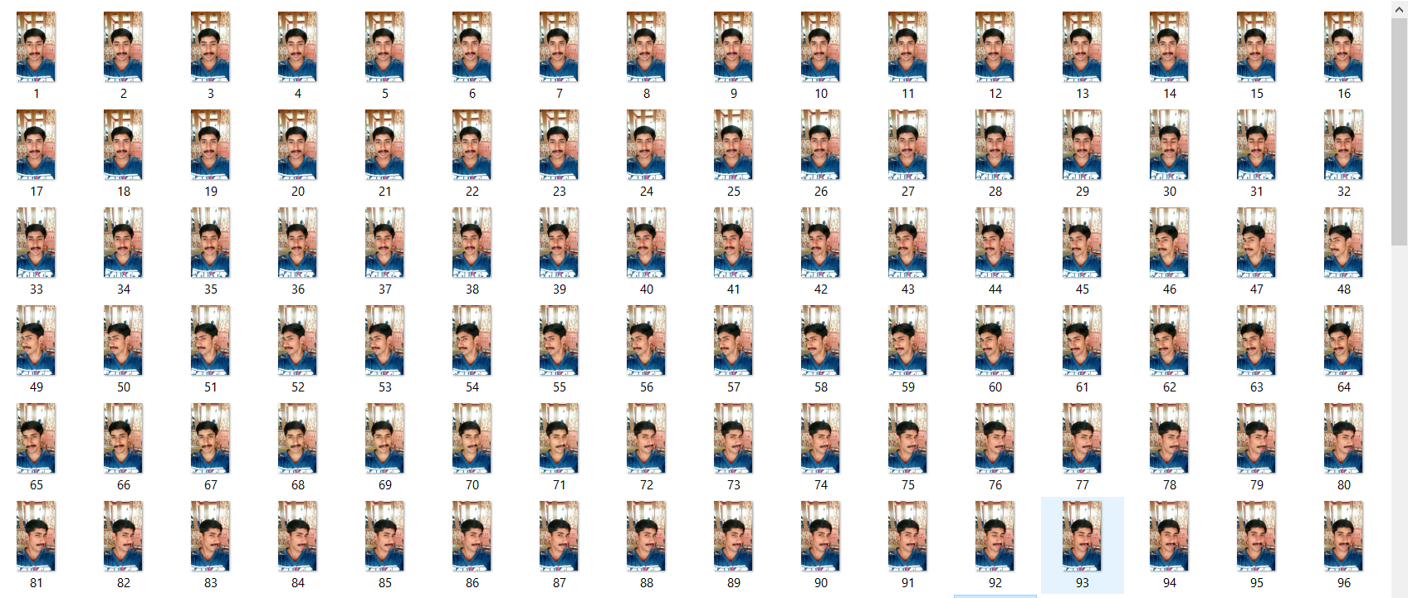

**Fig:6.2. (b) individual photo**

Fig 6.3 shows the folder of individual photos training file. This folder has sub folders for dataset, keras models were loaded and zipped files are created for training dataset.

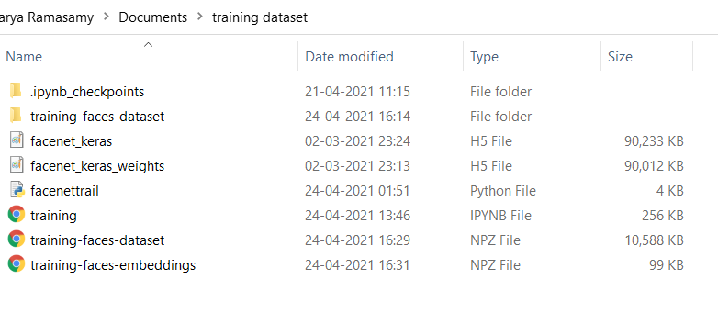**Fig:6.3. training dataset folder**

Fig 6.4 shows the output of training file. (213,160,160) indicates that 213 faces were trained with the dimension (160,160) and (213,128) indicates that face embeddings were created for 213 faces in 128 vector format.

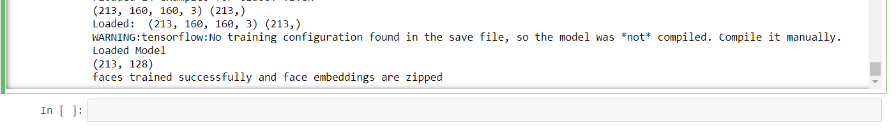

**Fig:6.4. training output**

FIG 6.5. shows The format in which faces are stored in array(160,160)

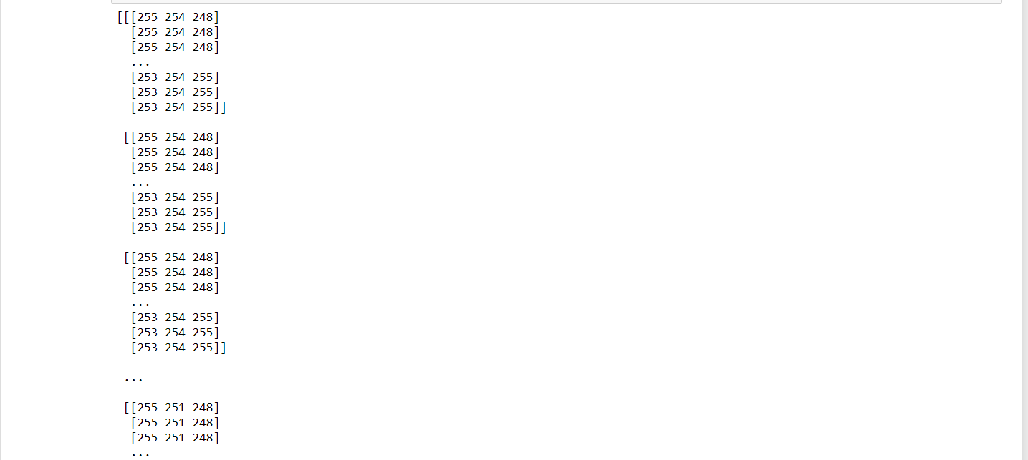

**fig 6.5 (a) array format of faces**

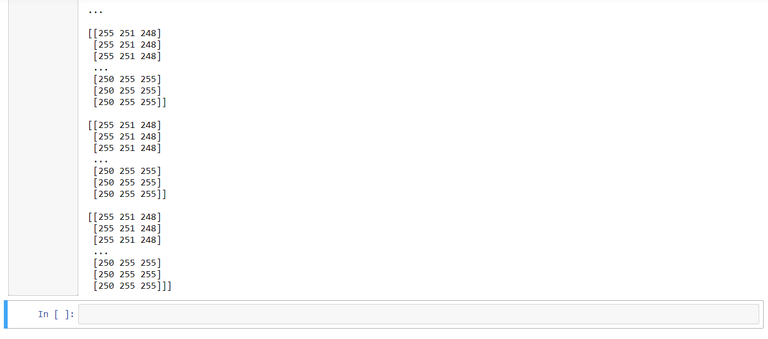

**fig 6.5 (b) array format of faces**

Fig 6.6 shows group photo for which YOLO is implemented.

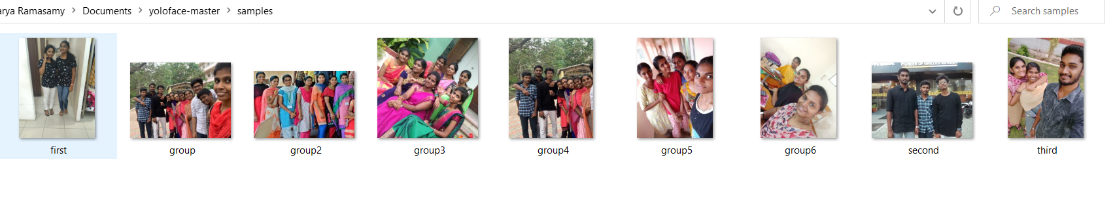

**Fig 6.6: sample group photos**

Fig.6.7(a) and (b) shows the output of YOLO with the bounding boxes indicating the detected faces and also the count of faces detected from photo.

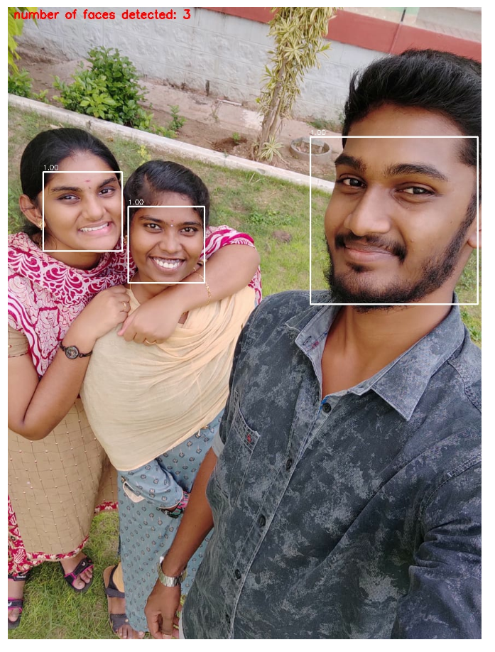

**Fig 6.7 (a) output from YOLO detection**

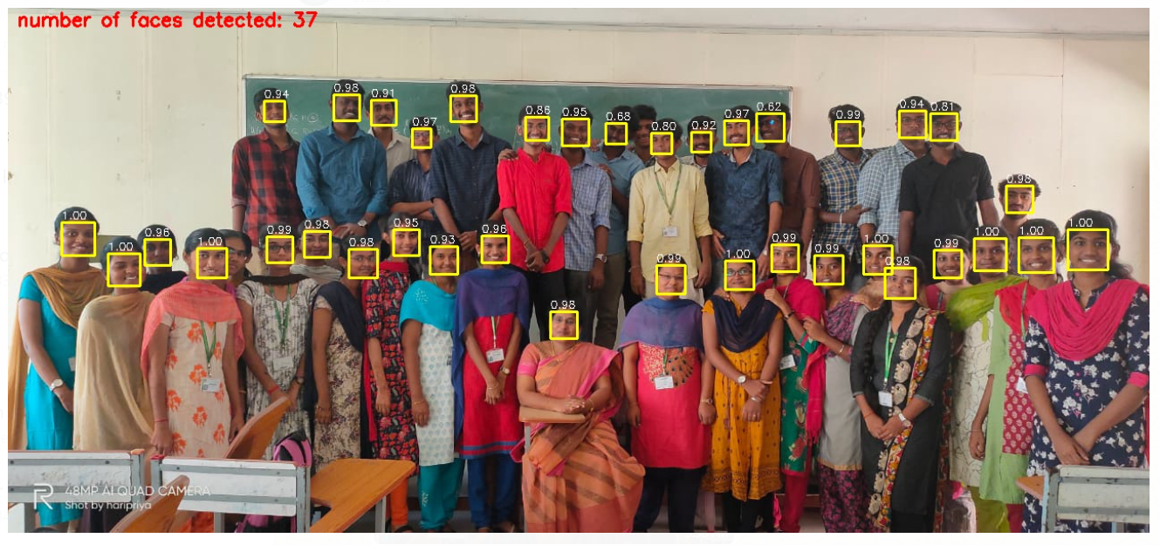

**Fig 6.7 (b) output from YOLO detection**

Fig.6.8 (a) and (b) shows the extracted face from the group photo. This is stored in dataset folder.

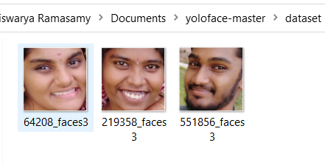

**Fig 6.8: (a) extracted faces**

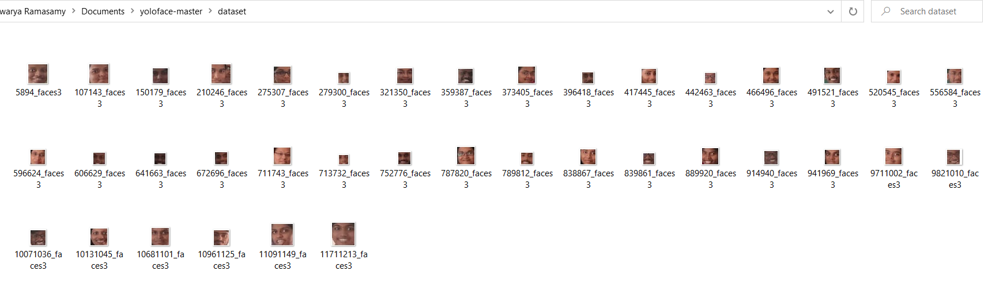

**Fig 6.8 (b)extracted faces**

Fig 6.9 shows the YOLO file compilation and the acknowledgement for the creation of output file.

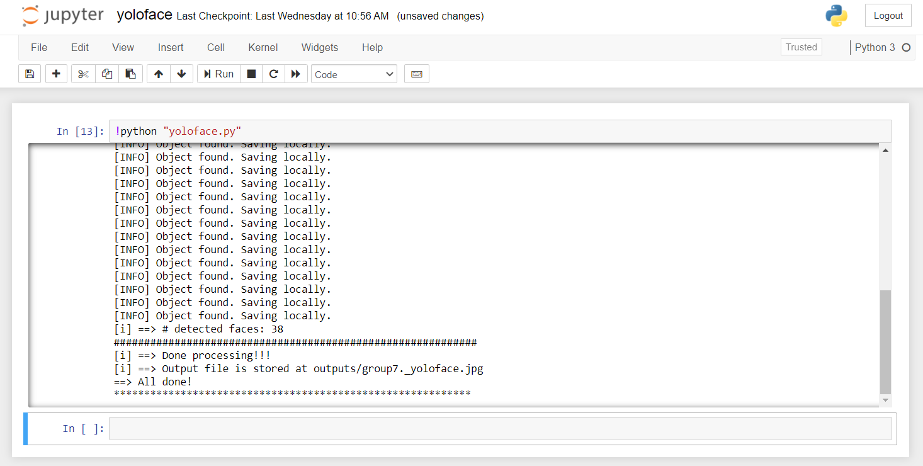

**Fig 6.9 output of YOLO file compilation**

Fig 6.10 shows the directory in which final attendance is marked.test-faces-embeddings is the embedded file of group photo. Keras file are uploaded in this directory for processing the faces

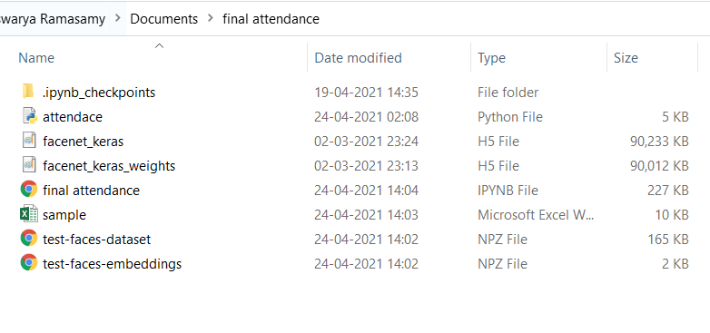**Fig. 6.10 directory of final attendance file**

Fig 6.11 shows the predicted faces with the correct names as per the prediction

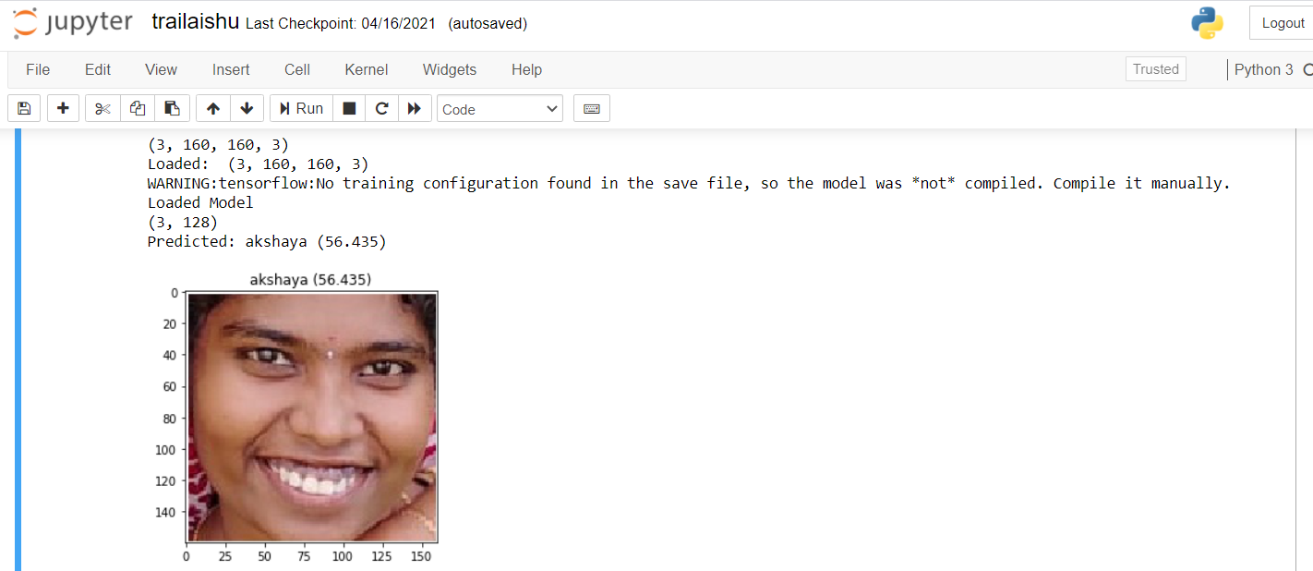

**Fig 6.11 (a) predicted faces with labels**

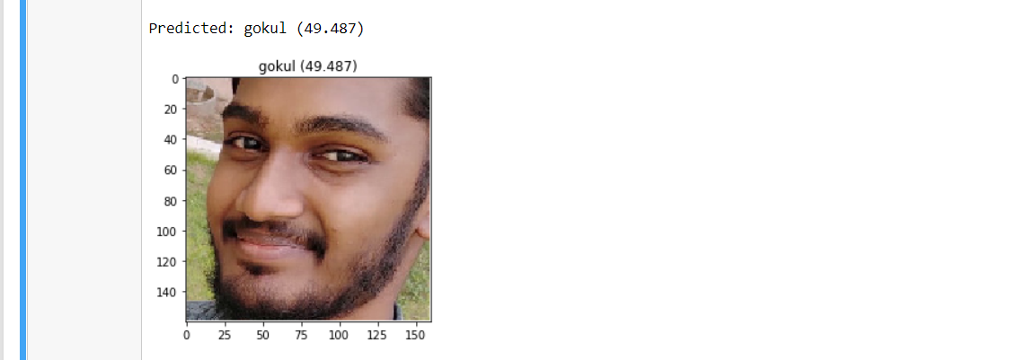

**Fig 6.11 (b) predicted faces with labels**

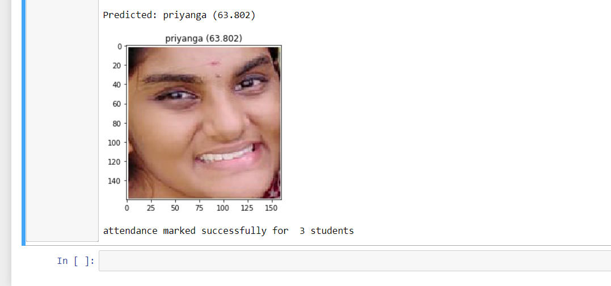

**Fig 6.11 (c) predicted faces with labels**

Fig 6.12 shows the excel sheet in which attendance will be uploaded for the year 2021



**Fig 6.12 sample.xlsx**

For each month separate sheets are used to update the attendance. Based on the month attendance is updated.



**Fig 6.13: separate sheets for each month**

Fig 6.14 shows that, Before marking the attendance the worksheet for the month April will be empty cells. first row shows the date from 1 to 30. First column shows the name of the employee.

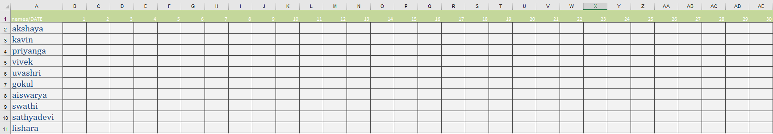

**Fig 6.14: excel sheet for April month before updating**

This excel sheet is for the month of April after updating the attendance.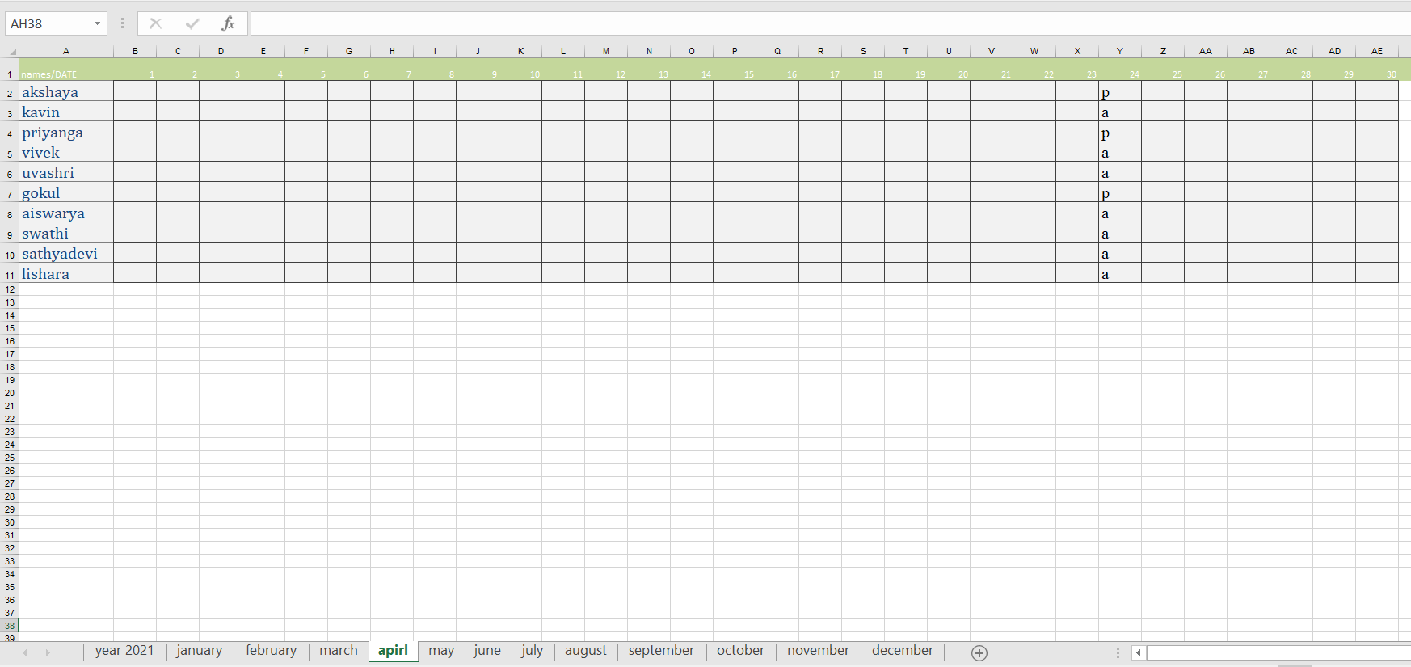

**Fig 6.15: worksheet for April month after updating**

**CONCLUSION AND FUTURE WORK**

**-----------------------------------------------------------------------------------**

**CHAPTER 7**

**CONCLUSION AND FUTURE WORK**

The main aim of the system is to ensure the welfare of the unskilled workers under the MGNREGA workers. The daily wages for the unskilled workers are not received properly though they are sincere to their work. This can be resolved using this intelligence attendance solution. This is cost effective and efficient method as it involves only the group photo of the workers to ensure their presence just with the help of a mobile phone. Further enhancement of this project is of two ways. First one is to include the workflow tracking of the individual MGNREGA workers. This can be implemented with the help of GPS tracking devices monitored by GPS master control stations which is responsible maintenance and corrections. Another way is to implement this project in institutions or universities where attendance is one of the mandatory work.

**REFERENCES**

**--------------------------------------------------------------------------------------**

**CHAPTER 8**

**REFERENCES**

1. Mayank Kumar Rusia , Dushyant Kumar Singh , Mohd.Aquib Ansari - Human Face Identification using LBP and Haar like Features for Real Time Attendance Monitoring,2019 Fifth International Conference on Image Information Processing (ICIIP)
2. Bharath Tej Chinimilli, Anjali T, Akhil Kotturi, Vihas Reddy Kaipu, Jathin Varma Mandapati

-Face Recognition based Attendance System using Haar Cascade and Local Binary Pattern Histogram Algorithm -Proceedings of the Fourth International Conference on Trends in Electronics and Informatics (ICOEI 2020) IEEE Xplore Part Number: CFP20J32-ART.

1. Rahul Chauhan, Kamal Kumar Ghanshala, R.C Joshi - Convolutional Neural Network (CNN) for Image Detection and Recognition - 2018 First International Conference on Secure Cyber Computing and Communication (ICSCCC).
2. Zhenguo Yuan - Face Detection and Recognition Based on Visual Attention Mechanism Guidance Model in Unrestricted Posture,Volume 2020,Article ID 8861987,Published 20 May 2020
3. [Veta Ghenescu](https://ieeexplore.ieee.org/author/37086430637) , [Roxana Elena Mihaescu](https://ieeexplore.ieee.org/author/37086430765), [Serban-Vasile Carata](https://ieeexplore.ieee.org/author/37085728526), [Marian Traian Ghenescu](https://ieeexplore.ieee.org/author/37085438899) - Face detection and recognition based on general purpose DNN object detector - [2018 International Symposium on Electronics and Telecommunications (ISETC)](https://ieeexplore.ieee.org/xpl/conhome/8556141/proceeding)
4. Dweepna Garg, Parth Goel, Sharnil Pandya, Amit Ganatra, Ketan Kotecha - A Deep Learning Approach for Face Detection using YOLO – 2018.
5. Ferry Cahyono, Wirawan, Reza Fuad Rachmadi - Face Recognition System using Facenet Algorithm for Employee Presence (2020)
6. Rudy Hartanto, Marcus Nurtiantoro Adji - Face Recognition for Attendance System Detection - 2018 10th International Conference on Information Technology and Electrical Engineering (ICITEE)
7. Marko Arsenovic, Srdjan Sladojevic, Andras Anderla, Darko Stefanovic - FaceTime – Deep Learning Based Face Recognition Attendance System - SISY 2017 , IEEE 15th International Symposium on Intelligent Systems and Informatics, September 14-16, 2017